LetsUpgrade JavaScript

Day 6 Assignment

**Question 1 (A)**

**HTML - index.html**

<!DOCTYPE html>

<html>

<head>

<meta charset="UTF-8">

<title>LetsUpgrade Assignment - crud</title>

<style>

*{ margin :0px;

padding : 0px; }

.data{height : 350px;

width : 75%;

background-color : #FBFFA1 ;

margin-left : 10%;

margin-top : 50px;

padding: 20px;}

.table{width : 100%;}

th,td{height : 40px;

text-align : center; }

</style></head>

<body><div class = "data">

<table border ="1" class = "table" cellspacing = "0">

<thead><tr>

<th>Sr no</th>

<th>Name</th>

<th>Age</th>

<th>City</th>

<th>Salary</th></tr>

</thead>

<tbody class = "tablebody"></tbody>

</table></div><script type = "text/javascript" src = "Day6.js"></script>

</body>

</html>

**Day6.js**

let information= [

{ name : "Rohit",

age : 29,

city : "Mumbai",

salary : 200000.00,},

{ name : "Kousi",

age : 21,

city : "Mumbai",

salary : 1500000.00,},

{ name : "John",

age : 31,

city : "Chennai",

salary : 30000.00,},

{ name : "Bella",

age : 21,

city : "New York",

salary : 175000.00,},

{ name : "Edward",

age : 46,

city : "Punjab",

salary : 210000.00,},];

function display(info){

let tabledata ="";

info.forEach(function(inf,index){

let cur_row = `<tr><td>${index+1}</td><td>${inf.name}</td><td>${inf.age}</td><td>${inf.city}</td><td>${inf.salary}</td></tr>`;

tabledata+=cur_row;});

document.getElementsByTagName("tbody")[0].innerHTML = tabledata;};

display(information);

**Output :**

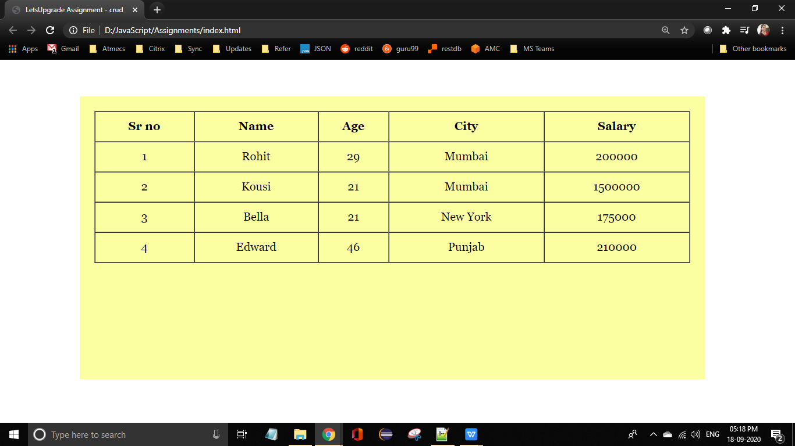

**Question 1 (B)**

**HTML - index.html**

<!DOCTYPE html>

<html>

<head>

<meta charset="UTF-8">

<title>LetsUpgrade Assignment - crud</title>

<style>

*{ margin :0px;

padding : 0px;}

.table{width : 100%;}

th,td{height : 40px;

text-align : center;}

.form{width : 100%;

padding-bottom : 10px;

padding-left:30px; }

button{height :30px;

width : 50px;

text-align : center;}

</style>

</head>

<body><div class = "data">

<div class = "form">

<input type = "text" placeholder = "Search Name" id = "srchName" onkeyup = "search()"/>

<input type = "text" placeholder = "Search City" id = "srchCity" onkeyup = "search()"/>

</div>

<table border ="1" class = "table" cellspacing = "0">

<thead><tr>

<th>Sr no</th>

<th>Name</th>

<th>Age</th>

<th>City</th>

<th>Salary</th></tr>

</thead> <tbody class = "tablebody"></tbody>

</table></div>

<script type = "text/javascript" src = "Day6.js"></script>

</body>

</html>

**Day6.js**

function display(info){

let tabledata ="";

info.forEach(function(inf,index){

let cur_row = `<tr><td>${index+1}</td><td>${inf.name}</td><td>${inf.age}</td><td>${inf.city}</td><td>${inf.salary}</td></tr>`;

tabledata+=cur_row; });

document.getElementsByTagName("tbody")[0].innerHTML = tabledata;};

display(information);

function search(){

let val1 = document.getElementById("srchName").value;

let val2 = document.getElementById("srchCity").value;

let filteredRows = information.filter(function(flt){

return ( flt.name.toUpperCase().indexOf(val1.toUpperCase()) != -1 && flt.city.toUpperCase().indexOf(val2.toUpperCase()) != -1);});

display(filteredRows);};

**Output :**

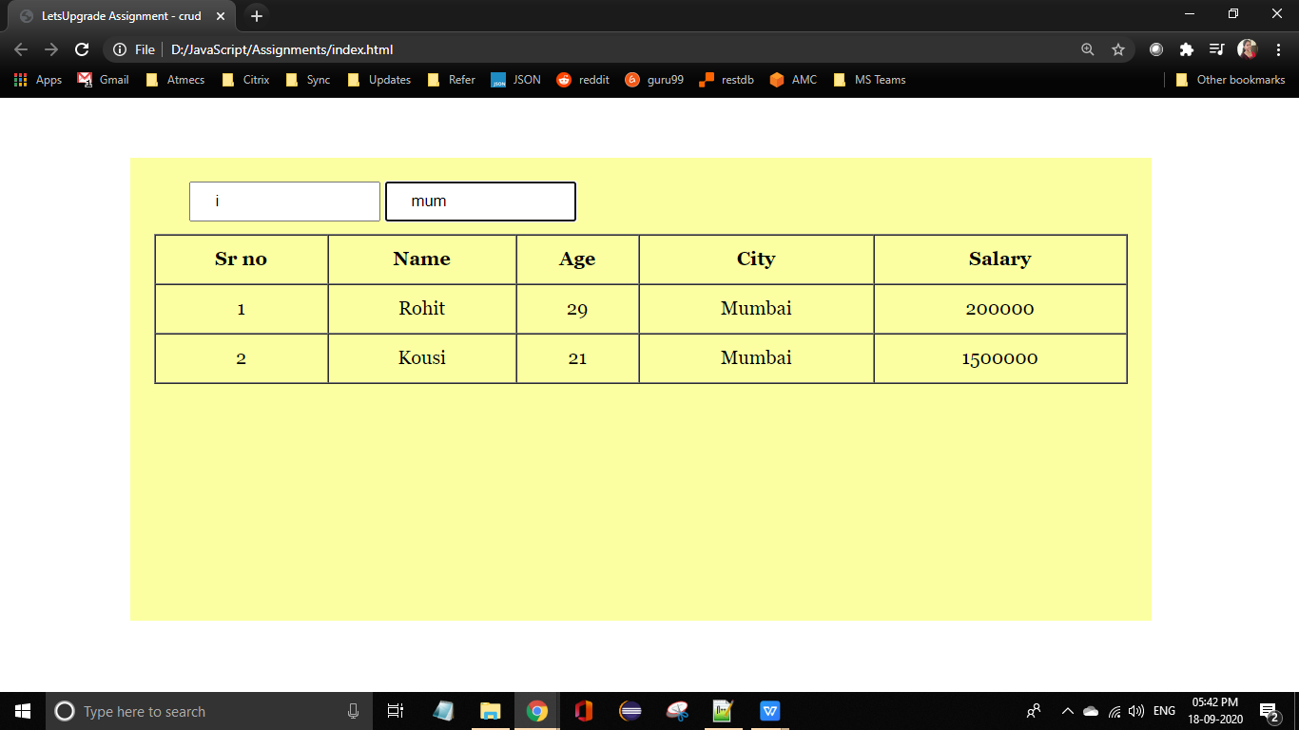

**Question 1 (C)**

**HTML - index.html**

<!DOCTYPE html>

<html>

<head>

<meta charset="UTF-8">

<title>LetsUpgrade Assignment - crud</title>

<style>

*{ margin :0px;

padding : 0px;}

.data{height : 350px;

width : 75%;

background-color : #FBFFA1 ;

margin-left : 10%;

margin-top : 50px;

padding: 20px; }

.table{width : 100%;}

th,td{height : 40px;

text-align : center; }

</style></head>

<body><div class = "data">

<table border ="1" class = "table" cellspacing = "0">

<thead><tr>

<th>Sr no</th>

<th>Name</th>

<th>Age</th>

<th>City</th>

<th>Salary</th>

<th>Delete</th> </tr>

</thead> <tbody class = "tablebody"></tbody>

</table></div>

<script type = "text/javascript" src = "Day6.js"></script>

</body>

</html>

**Day6.js**

function deleter(index){

information.splice(index,1);

display(information);

};

**Output :**

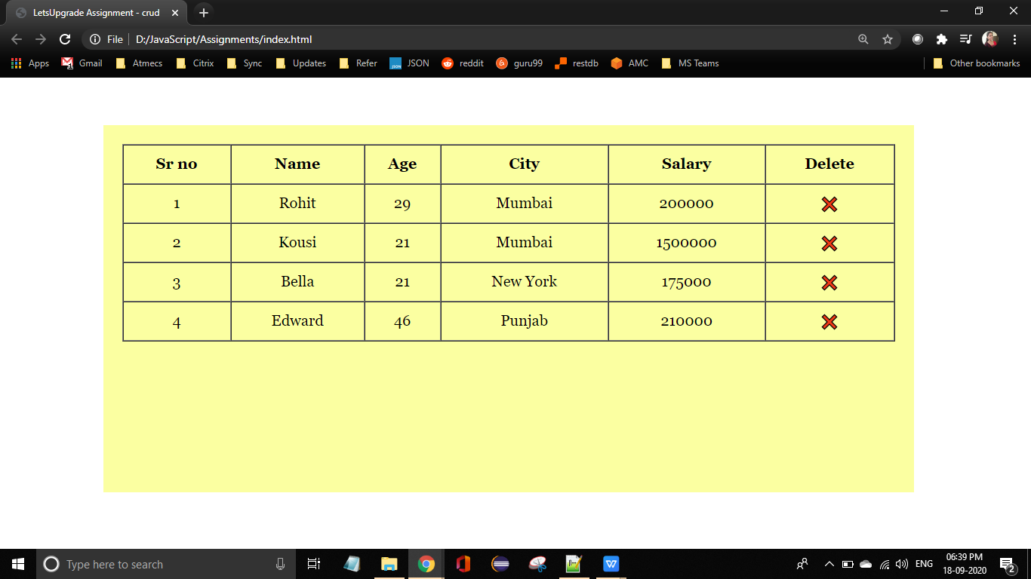

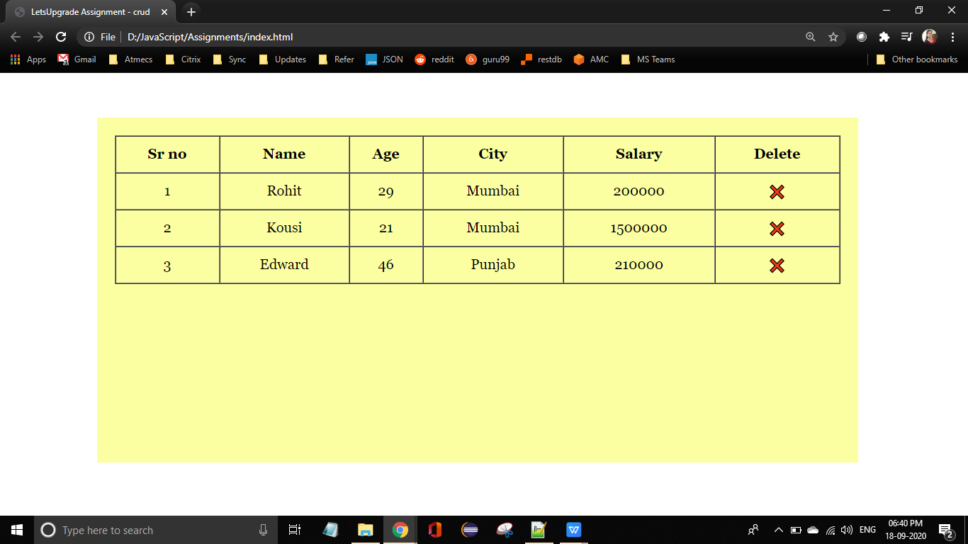

**Question 1 (D)**

When refreshed, all the changes made will go off. The data is not permanent.

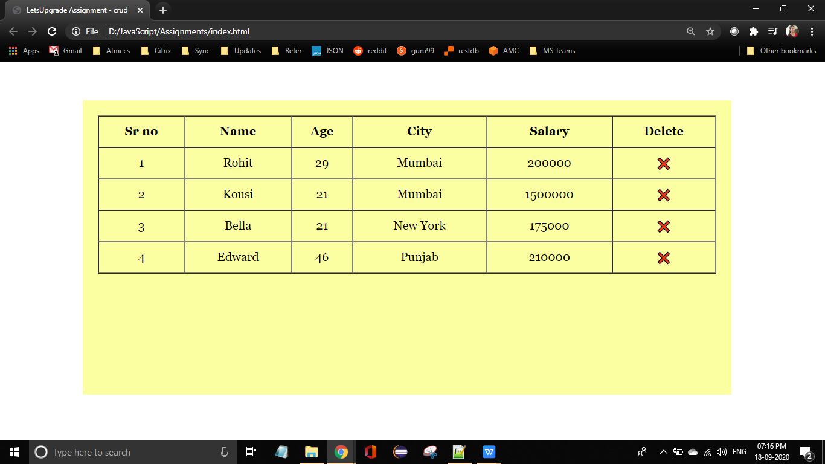

**Question 2 (A)**

**HTML - index.html**

<!DOCTYPE html>

<html>

<head>

<meta charset="UTF-8">

<title>LetsUpgrade Assignment - crud</title>

<style>

h3{margin-top : 25px;

text-align : center;mm}

.data{height : 300px;

width : 75%;

background-color : #FBFFA1 ;

margin-left : 12%;

margin-top : 1px;

padding: 10px; }

.table{width : 100%;}

th,td{height : 40px;

text-align : center;}

.form{width : 100%;

padding-left : 170px;

padding-bottom : 20px;}

input{height :30px;

text-indent :20px;}

button{height:32px;

width : 100px; }

</style></head>

<body>

<h3>Create and Display Buses</h3>

<div class = "form"><form onsubmit = "addrecord(event)">

<input type = "text" required placeholder = "Name" id = "name">

<input type = "text" required placeholder = "Source" id = "source">

<input type = "text" required placeholder = "Destination" id = "destination">

<input type = "number" required placeholder = "Number" id = "num">

<input type = "number" required placeholder = "Passenger Capacity" id = "capacity">

<button type = "Submit">Add Bus</button>

</form></div>

<div class = "data">

<table border ="1" class = "table" cellspacing = "0">

<thead> <tr>

<th width = 50px>S No</th>

<th width = 200 px>Name</th>

<th width = 200 px>Source</th>

<th width = 200 px>Destination</th>

<th>Number</th>

<th width = 200px>Passenger Capacity</th></tr>

</thead>

<tbody class = "tablebody"></tbody>

</table>

</div>

<script type = "text/javascript" src = "day5.js"></script>

</body>

</html>

**Output :**

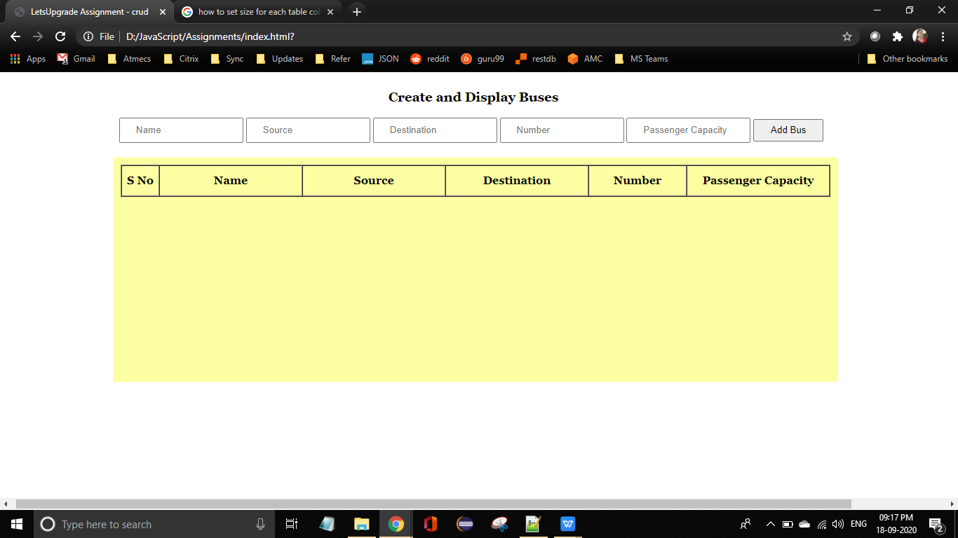

**Question 2 (B)**

**HTML - index.html**

Same as **2(A)**

**Day6.js**

let busInfo = [];

function display(info){

let tabledata ="";

info.forEach(function(inf,index){

let cur_row =

`<tr><td>${index+1}</td><td>${inf.name}</td><td>${inf.source}</td><td>${inf.destination}</td><td>${inf.number}</td><td>${inf.capacity}</td></tr>`;

tabledata+=cur_row;

});

document.getElementsByTagName("tbody")[0].innerHTML = tabledata;

};

function addrecord(e){

e.preventDefault();

let newdata={};

newdata.name = document.getElementById("name").value;

newdata.source = document.getElementById("source").value;

newdata.destination = document.getElementById("destination").value;

newdata.number = Number(document.getElementById("num").value);

newdata.capacity = Number(document.getElementById("capacity").value);

busInfo.push(newdata);

display(busInfo);

document.getElementById("name").value="";

document.getElementById("source").value="";

document.getElementById("destination").value="";

document.getElementById("number").value="";

document.getElementById("capacity").value="";

};

**Output :**

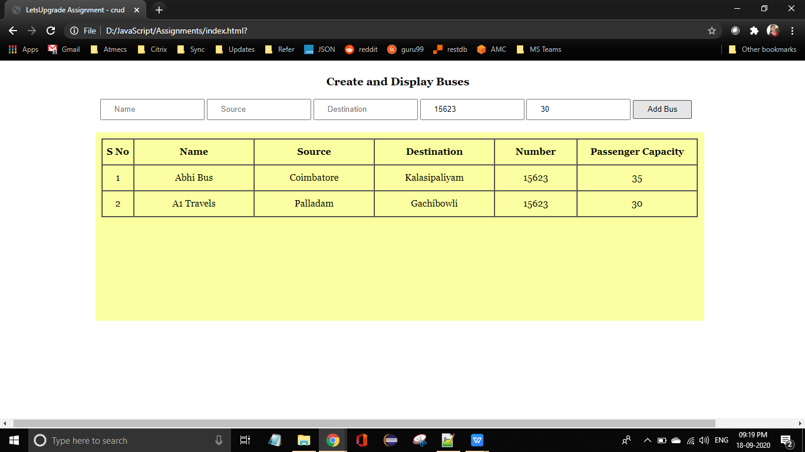

**Question 2 (C)**

**HTML - index.html**

<!DOCTYPE html>

<html>

<head>

<meta charset="UTF-8">

<title>LetsUpgrade Assignment - crud</title>

<style>

h3{margin-top : 25px;

text-align : center;mm}

.data{height : 300px;

width : 75%;

background-color : #FBFFA1 ;

margin-left : 12%;

margin-top : 1px;

padding: 10px; }

.table{width : 100%;}

th,td{height : 40px;

text-align : center;}

.form{width : 100%;

padding-left : 170px;

padding-bottom : 20px;}

input{height :30px;

text-indent :20px;}

button{height:32px;

width : 100px; }

</style></head>

<body>

<h3>Create and Display Buses</h3>

<div class = "form"><form onsubmit = "addrecord(event)">

<input type = "text" required placeholder = "Name" id = "name">

<input type = "text" required placeholder = "Source" id = "source">

<input type = "text" required placeholder = "Destination" id = "destination">

<input type = "number" required placeholder = "Number" id = "num">

<input type = "number" required placeholder = "Passenger Capacity" id = "capacity">

<button type = "Submit">Add Bus</button>

</form></div><div class = "form">

<input type = "text" placeholder = "Search Source" id = "srchSource" onkeyup = "search()"/>

<input type = "text" placeholder = "Search Destination" id = "srchDestination" onkeyup = "search()"/>

</div><div class = "data">

<table border ="1" class = "table" cellspacing = "0">

<thead> <tr>

<th width = 50px>S No</th>

<th width = 200 px>Name</th>

<th width = 200 px>Source</th>

<th width = 200 px>Destination</th>

<th>Number</th>

<th width = 200px>Passenger Capacity</th> </tr>

</thead> <tbody class = "tablebody"></tbody>

</table></div>

<script type = "text/javascript" src = "day5.js"></script>

</body>

</html>

**Day6.js**

let busInfo = [];

function display(info){

let tabledata ="";

info.forEach(function(inf,index){

let cur_row =

`<tr><td>${index+1}</td><td>${inf.name}</td><td>${inf.source}</td><td>${inf.destination}</td><td>${inf.number}</td><td>${inf.capacity}</td></tr>`;

tabledata+=cur_row; });

document.getElementsByTagName("tbody")[0].innerHTML = tabledata; };

function addrecord(e){

e.preventDefault();

let newdata={};

newdata.name = document.getElementById("name").value;

newdata.source = document.getElementById("source").value;

newdata.destination = document.getElementById("destination").value;

newdata.number = Number(document.getElementById("num").value);

newdata.capacity = Number(document.getElementById("capacity").value);

busInfo.push(newdata);

display(busInfo);

document.getElementById("name").value="";

document.getElementById("source").value="";

document.getElementById("destination").value="";

document.getElementById("number").value=null;

document.getElementById("capacity").value=null;};

function search(){

let val1 = document.getElementById("srchSource").value;

let val2 = document.getElementById("srchDestination").value;

let filteredRows = busInfo.filter(function(flt){

return ( flt.source.toUpperCase().indexOf(val1.toUpperCase()) != -1 && flt.destination.toUpperCase().indexOf (val2.toUpperCase()) != -1); });

display(filteredRows); };

**Output :**

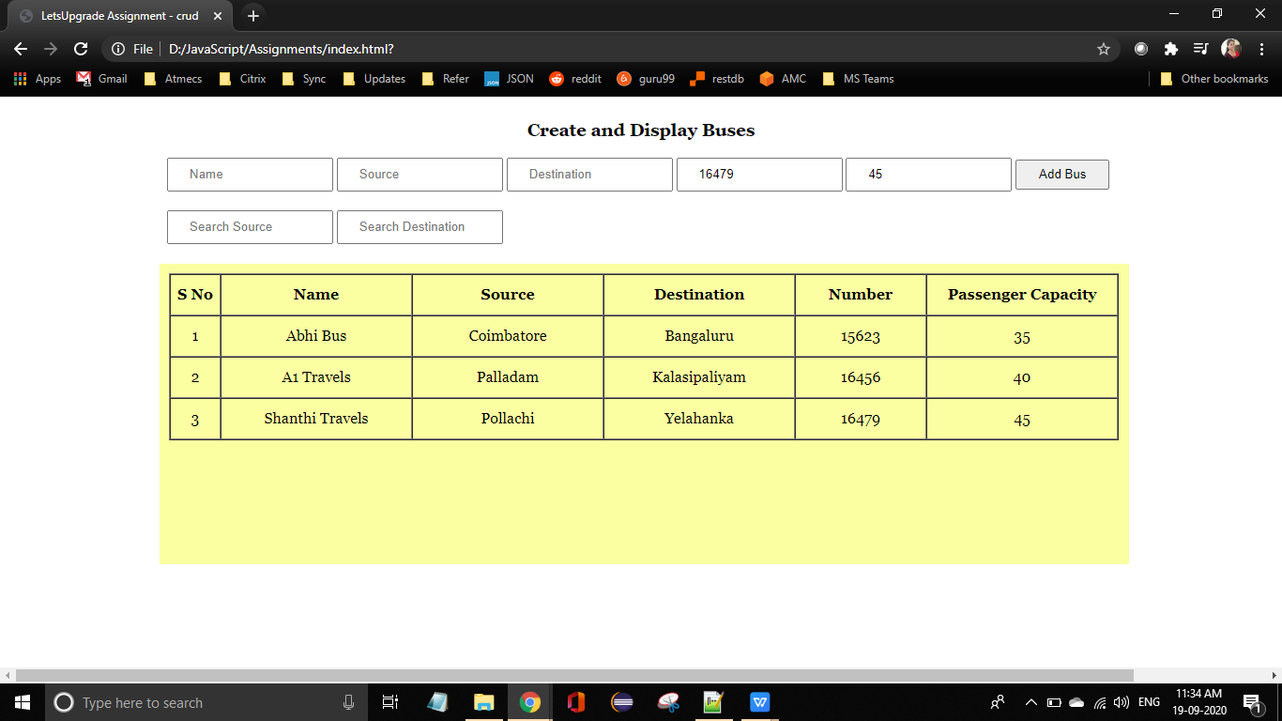

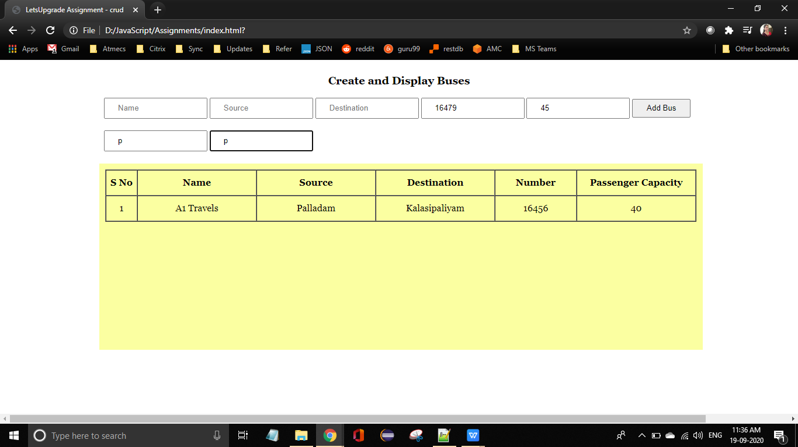

**Question 2 (D)**

**HTML - index.html**

<!DOCTYPE html>

<html>

<head>

<meta charset="UTF-8">

<title>LetsUpgrade Assignment - crud</title>

<style>

h3{margin-top : 25px;

text-align : center;mm}

.data{height : 300px;

width : 75%;

background-color : #FBFFA1 ;

margin-left : 12%;

margin-top : 1px;

padding: 10px; }

.table{width : 100%;}

th,td{height : 40px;

text-align : center;}

.form{width : 100%;

padding-left : 170px;

padding-bottom : 20px;}

input{height :30px;

text-indent :20px;}

button{height:32px;

width : 100px; }

</style></head>

<body>

<h3>Create and Display Buses</h3>

<div class = "form"><form onsubmit = "addrecord(event)">

<input type = "text" required placeholder = "Name" id = "name">

<input type = "text" required placeholder = "Source" id = "source">

<input type = "text" required placeholder = "Destination" id = "destination">

<input type = "number" required placeholder = "Number" id = "num">

<input type = "number" required placeholder = "Passenger Capacity" id = "capacity">

<button type = "Submit">Add Bus</button>

</form></div><div class = "form">

<input type = "text" placeholder = "Search Source" id = "srchSource" onkeyup = "search()"/>

<input type = "text" placeholder = "Search Destination" id = "srchDestination" onkeyup = "search()"/>

</div><div class = "data">

<table border ="1" class = "table" cellspacing = "0">

<thead> <tr>

<th width = 50px>S No</th>

<th width = 200px>Name</th>

<th width = 150px>Source</th>

<th width = 150px>Destination</th>

<th width = 130px>Number</th>

<th width = 150px>Passenger Capacity</th>

<th width = 50px></th> </tr>

</thead> <tbody class = "tablebody"></tbody>

</table></div>

<script type = "text/javascript" src = "day5.js"></script>

</body>

</html>

**Day6.js**

window.onload = function(){

let busInfo = [];

if(localStorage.getItem("busInfo") == null){

localStorage.setItem("busInfo", JSON.stringify(busInfo));

}

busInfo = JSON.parse(localStorage.getItem("busInfo"));

display(busInfo);

localStorage.setItem("busInfo",JSON.stringify(busInfo));};

function display(info){

let tabledata ="";

info.forEach(function(inf,index){

let cur_row =`<tr><td>${index+1}</td><td>${inf.name}</td><td>${inf.source}</td><td>${inf.

destination}</td><td>${inf.number}</td><td>${inf.capacity}</td><td onclick="deleter(${index})">❌</td></tr>`;

tabledata+=cur_row; });

document.getElementsByTagName("tbody")[0].innerHTML = tabledata; };

function addrecord(e){

e.preventDefault();

let newdata={};

newdata.name = document.getElementById("name").value;

newdata.source = document.getElementById("source").value;

newdata.destination = document.getElementById("destination").value;

newdata.number = Number(document.getElementById("num").value);

newdata.capacity = Number(document.getElementById("capacity").value);

let busInfo = JSON.parse(localStorage.getItem("busInfo"));

busInfo.push(newdata);

localStorage.setItem("busInfo",JSON.stringify(busInfo));

display(busInfo);

document.getElementById("name").value="";

document.getElementById("source").value="";

document.getElementById("destination").value="";

document.getElementById("num").value="";

document.getElementById("capacity").value=""; };

function search(){

busInfo = JSON.parse(localStorage.getItem("busInfo"));

let val1 = document.getElementById("srchSource").value;

let val2 = document.getElementById("srchDestination").value;

let filteredRows = busInfo.filter(function(flt){

return (flt.source.toUpperCase().indexOf(val1.toUpperCase()) != -1 && flt.destination. toUpperCase(). indexOf (val2.toUpperCase()) != -1); });

display(filteredRows);

localStorage.setItem("busInfo",JSON.stringify(busInfo));

};

function deleter(index){

let busInfo = JSON.parse(localStorage.getItem("busInfo"));

busInfo.splice(index,1);

display(busInfo);

localStorage.setItem("busInfo",JSON.stringify(busInfo));

};

**Output :**

